Assessment: Lab 8

Student Name: Zahi Masarwa

Lab Professor Name: Mel Sanschagrin

Lab Section Number: 303

Due Date: 04/09/21

# Pseudocode

Start

Declare Array int nums = {1,2,3,5,7}

Declare int counter=array length-1

Declare int sum=0;

While counter>=0{

Output nums[counter]

Sum=sum+ nums[counter]

Counter= counter-1

}

Output(arrays length)

Output (sum)

End

# Flowchart

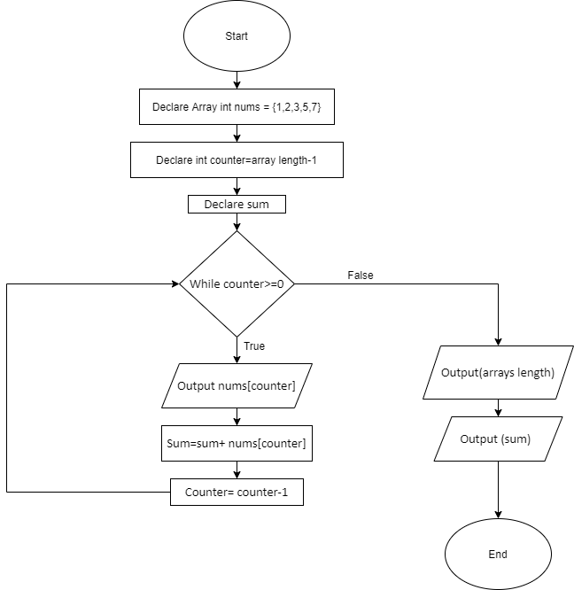

# Hand Trace Table

|  |  |  |  |
| --- | --- | --- | --- |
| Index value | Should Loop? | Output / Action  taken | Notes |
| 4 | yes | 7  Sum=7 | Loop prints value from index 4 of array, index decrement, sum add 7 to it value |
| 3 | yes | 5  Sum=12 | Loop prints value from index 3 of array, index decrement, sum add 5 to it value |
| 2 | yes | 3  Sum=15 | Loop prints value from index 2 of array, index decrement, sum add 3 to it value |
| 1 | yes | 2  Sum=17 | Loop prints value from index 1 of array, index decrement, sum add 2 to it value |
| 0 | Yes | 1  Sum=18 | Loop prints value from index 1 of array, index decrement, sum add 1 to it value |
| -1 | No |  | No loop, no output, no decrement to index |

# Conceptual Memory Map

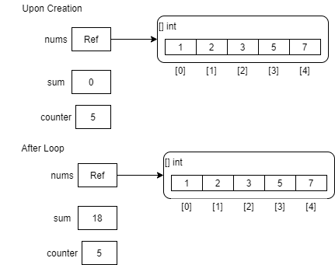

# Compile and Run Your Program

